XXXXXXX

PREFACE

In a company where the hierarchy of employees spans over thousand managing the work with them is a difficult job. And in an environment where number of jobs is done simultaneously picking the right person for the job is also difficult task, as you are not aware of their availability. This application is designed for such an environment where the work is divided into group of employees and during the course of division the employees are selected to be part of the work in hand.
This software being a web based is easily accessible from any corner of the company as every machine is part of a LAN network. The reason why it is made as a web application rather than a window based application if for the same reason. The complete task is divided into two types of users. Administrator (Highest authority), Manager (working group Community). The activities underlying these sections are as per the company policies.
This application provides most of the features required to manage the tasks developed in a firm.
This volume presents the manner in which the software was developed and how the various problems are tackled at the different levels to convince the user.
We hope that this package would prove to be an excellent environment to make Project Management simpler for end user.

Enter Your Name

CONTENTS

- INTRODUCTION
  - INTRODUCTION TO xxx
  - PURPOSE OF THE PROJECT
  - PROBLEM IN EXISTING SYSTEM
  - SOLUTION OF THESE PROBLEMS
  - SCOPE OF THE PROJECT

- PROJECT ANALYSIS
  - STUDY OF THE SYSTEM
  - HARDWARE & SOFTWARE SPECIFICATIONS
  - INPUT & OUTPUT
  - PROCESS MODELS USED WITH JUSTIFICATION

- SELECTED SOFTWARE

- SOFTWARE REQUIRMENT SPECIFICATION
- FUNCIONAL REQUIREMENTS
- PERFORMANCE REQUIREMENTS

- PROJECT DESIGN
- DATA DICTIONARY
- E-R DIAGRAM
- DATA FLOW DIAGRAMS

- OUTPUT SCREENS

7) PROJECT TESTING
  - COMPILING TEST
  - EXECUTION TEST
  - OUTPUT TEST

- FUTURE IMPROVEMENT

9) CONCLUSION

10) BIBLOGRAPHY

INTRODUCITON

Xxx SOFTWARE SOLUTIONS

xxx Software Solutions is an IT solution provider for a dynamic environment where business and technology strategies converge. Their approach focuses on new ways of business combining IT innovation and adoption while also leveraging an organization’s current IT assets. Their work with large global corporations and new products or services and to implement prudent business and technology strategies in today’s environment.

xxx’s range of expertise includes :

- Software Development Services
- Engineering Services
- Systems Integration
- Customer Relationship Management
- Product Development
- Electronic Commerce
- Consulting
- IT Outsourcing
We apply technology with innovation and responsibility to achieve two broad objectives:

- Effectively address the business issues our customers face today.
- Generate new opportunities that will help them stay ahead in the future.

This approach rests on :

- A strategy where we architect, integrate and manage technology services and solutions - we call it AIM for success.
- A robust offshore development methodology and reduced demand on customer resources.
- A focus on the use of reusable frameworks to provide cost and times benefits.

They combine the best people, processes and technology to achieve excellent results - consistency. We offer customers the advantages of:

Speed:
They understand the importance of timing, of getting there before the competition. A rich portfolio of reusable, modular frameworks helps jump-start projects. Tried and tested methodology ensures that we follow a predictable, low - risk path to achieve results. Our track record is testimony to complex projects delivered within and evens before schedule.

Expertise:
Our teams combine cutting edge technology skills with rich domain expertise. What’s equally important - they share a strong customer orientation that means they actually start by listening to the customer. They’re focused on coming up with solutions that serve customer requirements today and anticipate future needs.

A full service portfolio:
They offer customers the advantage of being able to Architect, integrate and manage technology services. This means that they can rely on one, fully accountable source instead of trying to integrate disparate multi vendor solutions.

Services:

Xxx is providing it’s services to companies which are in the field of production, quality control etc With their rich expertise and experience and information technology they are in best position to provide software solutions to distinct business requirements.

INTRODUCTION

- PURPOSE OF THE PROJECT

  - To develop a common interface for different sections of the firm.
  - The system should provide help in managing different tasks as well as the employees associated with the work.
  - Instant status of involvements of a person in the task.
  - To provide all the available members to be part of the team and easy selection procedure to make them available when required.
  - Security to the confidential information.
  - Reduce the redundancy of making the entries of the activities which are done manually.
  - To speed up the processing with in the firm.

- PROBLEMS IN THE EXISTING SYSTEM

  - The current system is a manual one where in the company maintains all the information in the form of records. There by collecting necessary information with require a manual search in the record(s).
  - Transfer of information between different sections of the enterprise is in the form of documents or letters. Drafting letters will take time.
  - Selection of a person for a task is done by manually approaching the person and confirming the availability of the person.
  - Due to mismanagement the work is delayed to later date than the due date.
  - Unavailability of proper information to different levels of employees with in the firm.

- SOLUTION OF THESE PROBLENS

- The information of the entire firm will be maintained at a centralized data base any changes made by the other departs are known to the higher or lower departments instantly.
- Provide Interactive interface through which a user can interact with different areas of application easily
- Deploy the application on a single system and make is available on all the systems with in the network, there by reducing the maintenance cost of software.
- Notification regarding the task allocation is done via a email which is a part of the application.

- SCOPE OF THE PROJECT

- Although the current system is confined to only one firm its performance is limited and restricted to the company. It spans over all the departments which can reach the server from their systems though lan network.
- The application is made as simple as surfing a website. There by non technical persons can also interact with the processing on the application easily.
- Provides instant information regarding the work under process with in the company.
- Easy management of data as located at a server.

- HARDWARE & SOFTWARE SPECIFICATIONS

- HARDWARE REQUIREMENTS:

PIII 500MHZ or above
128MB RAM
100MB Free Hard disk space
STD Color Monitor
Network interface card or Modem (For Remote Sources)
LAN Network (For Remote Sources)

- SOFTWARE REQUIREMENTS:

WINDOWS NT 4 | 2000 | 9.X | ME
Visual Studio .Net 2002 Enterprise Edition
Internet Information Server 5.0
Visual Studio .Net Framework (Minimal for Deployment)
SQL Server 2000

PROJECT ANALYSIS

- STUDY OF THE SYSTEM

The complete system can be divided into three halves on basis of access levels.

    - Administrator
    - Manager
Administrator:
An administrator is the main controller of the application. When compared to other types of users an administrator has an additional privilege to create new users manage applications and provide notifications. An administrator creates a new task, evey newly created task is placed in a specific group and is marked with status as open. Using the manage user Assignment the administrator will create of team of an individual person will be allotted with the task to be carried out.
Using the My preferences settings the creator will automatically get notified when ever the created task is changes. It also involves the display settings such as what kind if task list should be displayed whenever the user logs in and the no of tasks that should be shown when the user views the initial page. The preferences settings also includes the sorting of the available tasks based on various parameters, such as task types to display and their respective order. An administrator can also create new category of task lists, into which the future tasks can be placed.
The user management sections involve creating new users and managing existing users in terms of privilege given to them and changing passwords.
Application configuration involves placing the task list category with a status values. The different statuses are open, closed, in progress, intermediate etc.
Notification section includes the mechanism to notify the user with the proper message related to the tasks.
User:
A User is a restricted member of the application where in the user has the privileges to create new tasks manage the tasks and change the status of the application or placement of the application from one category to other category, it doesn’t posses the option of creating new users and management of applications.

ACCESS CONTROL FOR DATA WHICH REQUIRE USER AUTHENTICATION

The following commands specify access control identifiers and they are typically used to authorize and authenticate the user (command codes are
shown in parentheses)

USER NAME (USER)
- The user identification is that which is required by the server for access to its file system. This command will normally be the first command transmitted by the user after the control connections are made (some servers may require this).
PASSWORD (PASS)
- This command must be immediately preceded by the user name command, and, for some sites, completes the user's identification for access control. Since password information is quite sensitive, it is desirable in general to "mask" it or suppress type out.

SOFTWARE REQUIREMENT SPECIFICATION

SOFTWARE REQUIREMENT SPECIFICATION

REQUIREMENT SPECIFICATION:

The software, Techno Task Management is designed for management of the tasks with in a management environment of an organization.

INTRODUCTION

Purpose: The main purpose for preparing this document is to give a general insight into the analysis and requirements of the existing system or situation and for determining the operating characteristics of the system.

Scope: This Document plays a vital role in the development life cycle (SDLC)
As it describes the complete requirement of the system. It is meant for use by the developers and will be the basic during testing phase. Any changes made to the requirements in the future will have to go through formal change approval process.

Developers Responsibilities Overview:

The developer is responsible for:

1) Developing the system, which meets the SRS and solving all the requirements of the system?

2) Demonstrating the system and installing the system at client's location after the acceptance testing is successful.

3) Submitting the required user manual describing the system interfaces to work on it and also the documents of the system.

4) Conducting any user training that might be needed for using the system.

5) Maintaining the system for a period of one year after installation.

Functional Requirements:

OUTPUT DESIGN

Outputs from computer systems are required primarily to communicate the results of processing to users. They are also used to provides a permanent copy of the results for later consultation. The various types of outputs in general are:

- . External Outputs, whose destination is outside the organisation.
- . Internal Outputs whose destination is with in organisation and they are the
    - user’s main interface with the computer.
- . operational outputs whose use is purely with in the computer department.
- . Interface outputs, which involve the user in communicating directly with

Output Definition

The outputs should be defined in terms of the following points:

. Type of the output
. Content of the output
. Format of the output
Location of the output
.Frequency of the output
.Volume of the output
.Sequence of the output

It is not always desirable to print or display data as it is held on a computer. It should be decided as which form of the output is the most suitable.

For Example
. Will decimal points need to be inserted
. should leading zeros be suppressed.

Output Media:

In the next stage it is to be decided that which medium is the most appropriate for the output. The main considerations when decideing about the output media are:

.The suitability for the device to the particular application.
.The need for a hard copy.
.The response time required.
.The location of the users
.The software and hardware available.
The cost.

Keeping in view the above description the project is to have outputs mainly coming under the category of internal outputs. The main outputs desired according to the requirement specification are:

The outputs were needed to be generated as a hot copy and as well as queries to be viewed on the screen. Keeping in view these outputs, the format for the output is taken from the outputs, which are currently beeing obtained after manual processing. The standard printer is to be used as output media for hard copies.

INPUT DESIGN

Input design is a part of overall system design. The main objective during the input desing is as given below:

- To produce a cost-effective method of input.
- To achive the highest possible level of accuracy.
- To ensure that the input is acceptable and understood by the user.

INPUT STAGES:

The main input stages can be listed as below:

- Data recording
- Data transcription
- Data conversion
- Data verification
- Data control
- Data transmission
- Data validation
- Data correction

INPUT TYPES:

It is necessary to determine the various types of inputs. Inputs can be categorized as follows:

- External inputs, which are prime inputs for the system.
- Internal inputs, which are user communications with the system.
- Operational, which are computer department’s communications to the system?
- Interactive, which are inputs entered during a dialogue.

INPUT MEDIA:

At this stage choice has to be made about the input media. To conclude about the input media consideration has to be given to;

- Type of input
- Flexibility of format
- Speed
- Accuracy
- Verification methods
- Rejection rates
- Ease of correction
- Storage and handling requirements
- Security
- Easy to use
- Portabilility

Keeping in view the above description of the input types and input media, it can be said that most of the inputs are of the form of internal and interactive. As
Input data is to be the directly keyed in by the user, the keyboard can be considered to be the most suitable input device.

ERROR AVOIDANCE

At this stage care is to be taken to ensure that input data remains accurate form the stage at which it is recorded upto the stage in which the data is accepted by the system. This can be achieved only by means of careful control each time the data is handled.

ERROR DETECTION

Even though every effort is make to avoud the occurrence of errors, still a small proportion of errors is always likely to occur, these types of errors can be discovered by using validations to check the input data.

DATA VALIDATION

Procedures are designed to detect errors in data at a lower level of detail. Data validations have been included in the system in almost every area where there is a possibllity for the user to commit errors. The system will not accept invalid data. Whenever an invalid data is keyed in, the system immediately propts the user and the user has to again key in the data and the system will accept the data only if the data is correct. Validations have been included where necessary.

The system is designed to be a user friendly one. In other words the system has been designed to communicate effectively with the user. The system has been designed with pop up menus.

USERINTERGFACE DESIGN

It is essential to consult the system users and discuss their needs while designing the user interface:

USER INTERFACE SYSTEMS CAN BE BROADLY CLASIFIED AS:

- User initiated interface the user is in charge, controlling the progress of the user/computer dialogue. In the computer-initiated interface, the computer selects the next stage in the interaction.
- Computer initiated interfaces

In the computer initiated interfaces the computer guides the progress of the user/computer dialogue. Information is displayed and the user response of the computer takes action or displays further information.

USER_INITIATED INTERGFACES

User initiated interfaces fall into tow approximate classes:

- Command driven interfaces: In this type of interface the user inputs commands or queries which are interpreted by the computer.
- Forms oriented interface: The user calls up an image of the form to his/her screen and fills in the form. The forms oriented interface is chosen because it is the best choice.

COMPUTER-INITIATED INTERFACES

The following computer – initiated interfaces were used:

- The menu system for the user is presented with a list of alternatives and the user chooses one; of alternatives.
- Questions – answer type dialog system where the computer asks question and takes action based on the basis of the users reply.

Right from the start the system is going to be menu driven, the opening menu displays the available options. Choosing one option gives another popup menu with more options. In this way every option leads the users to data entry form where the user can key in the data.

ERROR MESSAGE DESIGN:

The design of error messages is an important part of the user interface design. As user is bound to commit some errors or other while designing a system the system should be designed to be helpful by providing the user with information regarding the error he/she has committed.

This application must be able to produce output at different modules for different inputs.

Performance Requirements:

Performance is measured in terms of the output provided by the application.

Requirement specification plays an important part in the analysis of a system. Only when the requirement specifications are properly given, it is possible to design a system, which will fit into required environment. It rests largely in the part of the users of the existing system to give the requirement specifications because they are the people who finally use the system. This is because the requirements have to be known during the initial stages so that the system can be designed according to those requirements. It is very difficult to change the system once it has been designed and on the other hand designing a system, which does not cater to the requirements of the user, is of no use.

The requirement specification for any system can be broadly stated as given below:

- The system should be able to interface with the existing system
- The system should be accurate
- The system should be better than the existing system

The existing system is completely dependent on the staff to perform all the duties.

SELECTED SOFTWARE

Microsoft.NET Framework
The .NET Framework is a new computing platform that simplifies application development in the highly distributed environment of the Internet. The .NET Framework is designed to fulfill the following objectives:
- To provide a consistent object-oriented programming environment whether object code is stored and executed locally, executed locally but Internet-distributed, or executed remotely.
- To provide a code-execution environment that minimizes software deployment and versioning conflicts.
- To provide a code-execution environment that guarantees safe execution of code, including code created by an unknown or semi-trusted third party.
- To provide a code-execution environment that eliminates the performance problems of scripted or interpreted environments.
- To make the developer experience consistent across widely varying types of applications, such as Windows-based applications and Web-based applications.
- To build all communication on industry standards to ensure that code based on the .NET Framework can integrate with any other code.
The .NET Framework has two main components: the common language runtime and the .NET Framework class library. The common language runtime is the foundation of the .NET Framework. You can think of the runtime as an agent that manages code at execution time, providing core services such as memory management, thread management, and remoting, while also enforcing strict type safety and other forms of code accuracy that ensure security and robustness. In fact, the concept of code management is a fundamental principle of the runtime. Code that targets the runtime is known as managed code, while code that does not target the runtime is known as unmanaged code. The class library, the other main component of the .NET Framework, is a comprehensive, object-oriented collection of reusable types that you can use to develop applications ranging from traditional command-line or graphical user interface (GUI) applications to applications based on the latest innovations provided by ASP.NET, such as Web Forms and XML Web services.
The .NET Framework can be hosted by unmanaged components that load the common language runtime into their processes and initiate the execution of managed code, thereby creating a software environment that can exploit both managed and unmanaged features. The .NET Framework not only provides several runtime hosts, but also supports the development of third-party runtime hosts.
For example, ASP.NET hosts the runtime to provide a scalable, server-side environment for managed code. ASP.NET works directly with the runtime to enable Web Forms applications and XML Web services, both of which are discussed later in this topic.
Internet Explorer is an example of an unmanaged application that hosts the runtime (in the form of a MIME type extension). Using Internet Explorer to host the runtime enables you to embed managed components or Windows Forms controls in HTML documents. Hosting the runtime in this way makes managed mobile code (similar to Microsoft® ActiveX® controls) possible, but with significant improvements that only managed code can offer, such as semi-trusted execution and secure isolated file storage.
The following illustration shows the relationship of the common language runtime and the class library to your applications and to the overall system. The illustration also shows how managed code operates within a larger architecture.

Features of the Common Language Runtime
The common language runtime manages memory, thread execution, code execution, code safety verification, compilation, and other system services. These features are intrinsic to the managed code that runs on the common language runtime.
With regards to security, managed components are awarded varying degrees of trust, depending on a number of factors that include their origin (such as the Internet, enterprise network, or local computer). This means that a managed component might or might not be able to perform file-access operations, registry-access operations, or other sensitive functions, even if it is being used in the same active application.
The runtime enforces code access security. For example, users can trust that an executable embedded in a Web page can play an animation on screen or sing a song, but cannot access their personal data, file system, or network. The security features of the runtime thus enable legitimate Internet-deployed software to be exceptionally feature rich.
The runtime also enforces code robustness by implementing a strict type- and code-verification infrastructure called the common type system (CTS). The CTS ensures that all managed code is self-describing. The various Microsoft and third-party language compilers
Generate managed code that conforms to the CTS. This means that managed code can consume other managed types and instances, while strictly enforcing type fidelity and type safety.
In addition, the managed environment of the runtime eliminates many common software issues. For example, the runtime automatically handles object layout and manages references to objects, releasing them when they are no longer being used. This automatic memory management resolves the two most common application errors, memory leaks and invalid memory references.
The runtime also accelerates developer productivity. For example, programmers can write applications in their development language of choice, yet take full advantage of the runtime, the class library, and components written in other languages by other developers. Any compiler vendor who chooses to target the runtime can do so. Language compilers that target the .NET Framework make the features of the .NET Framework available to existing code written in that language, greatly easing the migration process for existing applications.
While the runtime is designed for the software of the future, it also supports software of today and yesterday. Interoperability between managed and unmanaged code enables developers to continue to use necessary COM components and DLLs.
The runtime is designed to enhance performance. Although the common language runtime provides many standard runtime services, managed code is never interpreted. A feature called just-in-time (JIT) compiling enables all managed code to run in the native machine language of the system on which it is executing. Meanwhile, the memory manager removes the possibilities of fragmented memory and increases memory locality-of-reference to further increase performance.
Finally, the runtime can be hosted by high-performance, server-side applications, such as Microsoft® SQL Server™ and Internet Information Services (IIS). This infrastructure enables you to use managed code to write your business logic, while still enjoying the superior performance of the industry's best enterprise servers that support runtime hosting.

.NET Framework Class Library
The .NET Framework class library is a collection of reusable types that tightly integrate with the common language runtime. The class library is object oriented, providing types from which your own managed code can derive functionality. This not only makes the .NET Framework types easy to use, but also reduces the time associated with learning new
features of the .NET Framework. In addition, third-party components can integrate seamlessly with classes in the .NET Framework.
For example, the .NET Framework collection classes implement a set of interfaces that you can use to develop your own collection classes. Your collection classes will blend seamlessly with the classes in the .NET Framework.
As you would expect from an object-oriented class library, the .NET Framework types enable you to accomplish a range of common programming tasks, including tasks such as string management, data collection, database connectivity, and file access. In addition to these common tasks, the class library includes types that support a variety of specialized development scenarios. For example, you can use the .NET Framework to develop the following types of applications and services:
- Console applications.
- Scripted or hosted applications.
- Windows GUI applications (Windows Forms).
- ASP.NET applications.
- XML Web services.
- Windows services.
For example, the Windows Forms classes are a comprehensive set of reusable types that vastly simplify Windows GUI development. If you write an ASP.NET Web Form application, you can use the Web Forms classes.

Client Application Development
Client applications are the closest to a traditional style of application in Windows-based programming. These are the types of applications that display windows or forms on the desktop, enabling a user to perform a task. Client applications include applications such as word processors and spreadsheets, as well as custom business applications such as data-entry tools, reporting tools, and so on. Client applications usually employ windows, menus, buttons, and other GUI elements, and they likely access local resources such as the file system and peripherals such as printers.
Another kind of client application is the traditional ActiveX control (now replaced by the managed Windows Forms control) deployed over the Internet as a Web page. This application is much like other client applications: it is executed natively, has access to local resources, and includes graphical elements.

In the past, developers created such applications using C/C++ in conjunction with the Microsoft Foundation Classes (MFC) or with a rapid application development (RAD) environment such as Microsoft® Visual Basic®. The .NET Framework incorporates aspects of these existing products into a single, consistent development environment that drastically simplifies the development of client applications.
The Windows Forms classes contained in the .NET Framework are designed to be used for GUI development. You can easily create command windows, buttons, menus, toolbars, and other screen elements with the flexibility necessary to accommodate shifting business needs.
For example, the .NET Framework provides simple properties to adjust visual attributes associated with forms. In some cases the underlying operating system does not support changing these attributes directly, and in these cases the .NET Framework automatically recreates the forms. This is one of many ways in which the .NET Framework integrates the developer interface, making coding simpler and more consistent.
Unlike ActiveX controls, Windows Forms controls have semi-trusted access to a user's computer. This means that binary or natively executing code can access some of the resources on the user's system (such as GUI elements and limited file access) without being able to access or compromise other resources. Because of code access security, many applications that once needed to be installed on a user's system can now be safely deployed through the Web. Your applications can implement the features of a local application while being deployed like a Web page.

C#.NET

Introduction to Windows Forms (C#.NET)
ACTIVE X DATA OBJECTS.NET

ADO.NET Overview

ADO.NET is an evolution of the ADO data access model that directly addresses user requirements for developing scalable applications. It was designed specifically for the web with scalability, statelessness, and XML in mind.
ADO.NET uses some ADO objects, such as the Connection and Command objects, and also introduces new objects. Key new ADO.NET objects include the DataSet, DataReader, and DataAdapter.
The important distinction between this evolved stage of ADO.NET and previous data architectures is that there exists an object -- the DataSet -- that is separate and distinct from any data stores. Because of that, the DataSet functions as a standalone entity. You can think of the DataSet as an always disconnected recordset that knows nothing about the source or destination of the data it contains. Inside a DataSet, much like in a database, there are tables, columns, relationships, constraints, views, and so forth.
A DataAdapter is the object that connects to the database to fill the DataSet. Then, it connects back to the database to update the data there, based on operations performed while the DataSet held the data. In the past, data processing has been primarily connection-based. Now, in an effort to make multi-tiered apps more efficient, data processing is turning to a message-based approach that revolves around chunks of information. At the center of this approach is the DataAdapter, which provides a bridge to retrieve and save data between a DataSet and its source data store. It accomplishes this by means of requests to the appropriate SQL commands made against the data store.
The XML-based DataSet object provides a consistent programming model that works with all models of data storage: flat, relational, and hierarchical. It does this by having no 'knowledge' of the source of its data, and by representing the data that it holds as collections and data types. No matter what the source of the data within the DataSet is, it is manipulated through the same set of standard APIs exposed through the DataSet and its subordinate objects.
While the DataSet has no knowledge of the source of its data, the managed provider has detailed and specific information. The role of the managed provider is to connect, fill, and persist the DataSet to and from data stores. The OLE DB and SQL Server .NET Data Providers (System.Data.OleDb and System.Data.SqlClient) that are part of the .Net Framework provide four basic objects: the Command, Connection, DataReader and DataAdapter. In the remaining sections of this document, we'll walk through each part of the DataSet and the OLE DB/SQL Server .NET Data Providers explaining what they are, and how to program against them.
The following sections will introduce you to some objects that have evolved, and some that are new. These objects are:
- Connections. For connection to and managing transactions against a database.
- Commands. For issuing SQL commands against a database.
- DataReaders. For reading a forward-only stream of data records from a SQL Server data source.
- DataSets. For storing, remoting and programming against flat data, XML data and relational data.
- DataAdapters. For pushing data into a DataSet, and reconciling data against a database.
When dealing with connections to a database, there are two different options: SQL Server .NET Data Provider (System.Data.SqlClient) and OLE DB .NET Data Provider (System.Data.OleDb). In these samples we will use the SQL Server .NET Data Provider. These are written to talk directly to Microsoft SQL Server. The OLE DB .NET Data Provider is used to talk to any OLE DB provider (as it uses OLE DB underneath).
Connections
Connections are used to 'talk to' databases, and are respresented by provider-specific classes such as SQLConnection. Commands travel over connections and resultsets are returned in the form of streams which can be read by a DataReader object, or pushed into a DataSet object.
Commands
Commands contain the information that is submitted to a database, and are represented by provider-specific classes such as SQLCommand. A command can be a stored procedure call, an UPDATE statement, or a statement that returns results. You can also use input and output parameters, and return values as part of your command syntax. The example below shows how to issue an INSERT statement against the Northwind database.
DataReaders
The DataReader object is somewhat synonymous with a read-only/forward-only cursor over data. The DataReader API supports flat as well as hierarchical data. A DataReader object is returned after executing a command against a database. The format of the returned DataReader object is different from a recordset. For example, you might use the DataReader to show the results of a search list in a web page.
DataSets and DataAdapters
DataSets
The DataSet object is similar to the ADO Recordset object, but more powerful, and with one other important distinction: the DataSet is always disconnected. The DataSet object represents a cache of data, with database-like structures such as tables, columns, relationships, and constraints. However, though a DataSet can and does behave much like a database, it is important to remember that DataSet objects do not interact directly with databases, or other source data. This allows the developer to work with a programming model that is always consistent, regardless of where the source data resides. Data coming from a database, an XML file, from code, or user input can all be placed into DataSet objects. Then, as changes are made to the DataSet they can be tracked and verified before updating the source data. The GetChanges method of the DataSet object actually creates a second DatSet that contains only the changes to the data. This DataSet is then used by a DataAdapter (or other objects) to update the original data source.
The DataSet has many XML characteristics, including the ability to produce and consume XML data and XML schemas. XML schemas can be used to describe schemas interchanged via WebServices. In fact, a DataSet with a schema can actually be compiled for type safety and statement completion.
DataAdapters (OLEDB/SQL)
The DataAdapter object works as a bridge between the DataSet and the source data. Using the provider-specific SqlDataAdapter (along with its associated SqlCommand and SqlConnection) can increase overall performance when working with a Microsoft SQL Server databases. For other OLE DB-supported databases, you would use the OleDbDataAdapter object and its associated OleDbCommand and OleDbConnection objects.
The DataAdapter object uses commands to update the data source after changes have been made to the DataSet. Using the Fill method of the DataAdapter calls the SELECT command; using the Update method calls the INSERT, UPDATE or DELETE command for each changed row. You can explicitly set these commands in order to control the statements used at runtime to resolve changes, including the use of stored procedures. For ad-hoc scenarios, a CommandBuilder object can generate these at run-time based upon a select statement. However, this run-time generation requires an extra round-trip to the server in order to gather required metadata, so explicitly providing the INSERT, UPDATE, and DELETE commands at design time will result in better run-time performance.
- ADO.NET is the next evolution of ADO for the .Net Framework.
- ADO.NET was created with n-Tier, statelessness and XML in the forefront. Two new objects, the DataSet and DataAdapter, are provided for these scenarios.
- ADO.NET can be used to get data from a stream, or to store data in a cache for updates.
- There is a lot more information about ADO.NET in the documentation.
- Remember, you can execute a command directly against the database in order to do inserts, updates, and deletes. You don't need to first put data into a DataSet in order to insert, update, or delete it.
- Also, you can use a DataSet to bind to the data, move through the data, and navigate data relationships

ASP.Net

Server Application Development
Server-side applications in the managed world are implemented through runtime hosts. Unmanaged applications host the common language runtime, which allows your custom managed code to control the behavior of the server. This model provides you with all the features of the common language runtime and class library while gaining the performance and scalability of the host server.
The following illustration shows a basic network schema with managed code running in different server environments. Servers such as IIS and SQL Server can perform standard operations while your application logic executes through the managed code.
Server-side managed code
ASP.NET is the hosting environment that enables developers to use the .NET Framework to target Web-based applications. However, ASP.NET is more than just a runtime host; it is a complete architecture for developing Web sites and Internet-distributed objects using managed code. Both Web Forms and XML Web services use IIS and ASP.NET as the publishing mechanism for applications, and both have a collection of supporting classes in the .NET Framework.
XML Web services, an important evolution in Web-based technology, are distributed, server-side application components similar to common Web sites. However, unlike Web-based applications, XML Web services components have no UI and are not targeted for browsers such as Internet Explorer and Netscape Navigator. Instead, XML Web services consist of reusable software components designed to be consumed by other applications, such as traditional client applications, Web-based applications, or even other XML Web services. As a result, XML Web services technology is rapidly moving application development and deployment into the highly distributed environment of the Internet.
If you have used earlier versions of ASP technology, you will immediately notice the improvements that ASP.NET and Web Forms offers. For example, you can develop Web Forms pages in any language that supports the .NET Framework. In addition, your code no longer needs to share the same file with your HTTP text (although it can continue to do so if you prefer). Web Forms pages execute in native machine language because, like any other managed application, they take full advantage of the runtime. In contrast, unmanaged ASP pages are always scripted and interpreted. ASP.NET pages are faster, more functional, and easier to develop than unmanaged ASP pages because they interact with the runtime like any managed application.
The .NET Framework also provides a collection of classes and tools to aid in development and consumption of XML Web services applications. XML Web services are built on standards such as SOAP (a remote procedure-call protocol), XML (an extensible data format), and WSDL ( the Web Services Description Language). The .NET Framework is built on these standards to promote interoperability with non-Microsoft solutions.
For example, the Web Services Description Language tool included with the .NET Framework SDK can query an XML Web service published on the Web, parse its WSDL description, and produce C# or Visual Basic source code that your application can use to become a client of the XML Web service. The source code can create classes derived from classes in the class library that handle all the underlying communication using SOAP and XML parsing. Although you can use the class library to consume XML Web services directly, the Web Services Description Language tool and the other tools contained in the SDK facilitate your development efforts with the .NET Framework.
If you develop and publish your own XML Web service, the .NET Framework provides a set of classes that conform to all the underlying communication standards, such as SOAP, WSDL, and XML. Using those classes enables you to focus on the logic of your service, without concerning yourself with the communications infrastructure required by distributed software development.
Finally, like Web Forms pages in the managed environment, your XML Web service will run with the speed of native machine language using the scalable communication of IIS.

Active Server Pages.NET

ASP.NET is a programming framework built on the common language runtime that can be used on a server to build powerful Web applications. ASP.NET offers several important advantages over previous Web development models:
- Enhanced Performance. ASP.NET is compiled common language runtime code running on the server. Unlike its interpreted predecessors, ASP.NET can take advantage of early binding, just-in-time compilation, native optimization, and caching services right out of the box. This amounts to dramatically better performance before you ever write a line of code.
- World-Class Tool Support. The ASP.NET framework is complemented by a rich toolbox and designer in the Visual Studio integrated development environment. WYSIWYG editing, drag-and-drop server controls, and automatic deployment are just a few of the features this powerful tool provides.
- Power and Flexibility. Because ASP.NET is based on the common language runtime, the power and flexibility of that entire platform is available to Web application developers. The .NET Framework class library, Messaging, and Data Access solutions are all seamlessly accessible from the Web. ASP.NET is also language-independent, so you can choose the language that best applies to your application or partition your application across many languages. Further, common language runtime interoperability guarantees that your existing investment in COM-based development is preserved when migrating to ASP.NET.
- Simplicity. ASP.NET makes it easy to perform common tasks, from simple form submission and client authentication to deployment and site configuration. For example, the ASP.NET page framework allows you to build user interfaces that cleanly separate application logic from presentation code and to handle events in a simple, Visual Basic - like forms processing model. Additionally, the common language runtime simplifies development, with managed code services such as automatic reference counting and garbage collection.
- Manageability. ASP.NET employs a text-based, hierarchical configuration system, which simplifies applying settings to your server environment and Web applications. Because configuration information is stored as plain text, new settings may be applied without the aid of local administration tools. This "zero local administration" philosophy extends to deploying ASP.NET Framework applications as well. An ASP.NET Framework application is deployed to a server simply by copying the necessary files to the server. No server restart is required, even to deploy or replace running compiled code.
- Scalability and Availability. ASP.NET has been designed with scalability in mind, with features specifically tailored to improve performance in clustered and multiprocessor environments. Further, processes are closely monitored and managed by the ASP.NET runtime, so that if one misbehaves (leaks, deadlocks), a new process can be created in its place, which helps keep your application constantly available to handle requests.
- Customizability and Extensibility. ASP.NET delivers a well-factored architecture that allows developers to "plug-in" their code at the appropriate level. In fact, it is possible to extend or replace any subcomponent of the ASP.NET runtime with your own custom-written component. Implementing custom authentication or state services has never been easier.
- Security. With built in Windows authentication and per-application configuration, you can be assured that your applications are secure.

Language Support

The Microsoft .NET Platform currently offers built-in support for three languages: C#, Visual Basic, and JScript.

What is ASP.NET Web Forms?
The ASP.NET Web Forms page framework is a scalable common language runtime programming model that can be used on the server to dynamically generate Web pages.
Intended as a logical evolution of ASP (ASP.NET provides syntax compatibility with existing pages), the ASP.NET Web Forms framework has been specifically designed to address a number of key deficiencies in the previous model. In particular, it provides:
- The ability to create and use reusable UI controls that can encapsulate common functionality and thus reduce the amount of code that a page developer has to write.
- The ability for developers to cleanly structure their page logic in an orderly fashion (not "spaghetti code").
- The ability for development tools to provide strong WYSIWYG design support for pages (existing ASP code is opaque to tools).
ASP.NET Web Forms pages are text files with an .aspx file name extension. They can be deployed throughout an IIS virtual root directory tree. When a browser client requests .aspx resources, the ASP.NET runtime parses and compiles the target file into a .NET Framework class. This class can then be used to dynamically process incoming requests. (Note that the .aspx file is compiled only the first time it is accessed; the compiled type instance is then reused across multiple requests).
An ASP.NET page can be created simply by taking an existing HTML file and changing its file name extension to .aspx (no modification of code is required). For example, the following sample demonstrates a simple HTML page that collects a user's name and category preference and then performs a form postback to the originating page when a button is clicked:
ASP.NET provides syntax compatibility with existing ASP pages. This includes support for <% %> code render blocks that can be intermixed with HTML content within an .aspx file. These code blocks execute in a top-down manner at page render time.

Code-Behind Web Forms
ASP.NET supports two methods of authoring dynamic pages. The first is the method shown in the preceding samples, where the page code is physically declared within the originating .aspx file. An alternative approach--known as the code-behind method--enables the page code to be more cleanly separated from the HTML content into an entirely separate file.
Introduction to ASP.NET Server Controls
In addition to (or instead of) using <% %> code blocks to program dynamic content, ASP.NET page developers can use ASP.NET server controls to program Web pages. Server controls are declared within an .aspx file using custom tags or intrinsic HTML tags that contain a runat="server" attribute value. Intrinsic HTML tags are handled by one of the controls in the System.Web.UI.HtmlControls namespace. Any tag that doesn't explicitly map to one of the controls is assigned the type of System.Web.UI.HtmlControls.HtmlGenericControl.
Server controls automatically maintain any client-entered values between round trips to the server. This control state is not stored on the server (it is instead stored within an <input type="hidden"> form field that is round-tripped between requests). Note also that no client-side script is required.
In addition to supporting standard HTML input controls, ASP.NET enables developers to utilize richer custom controls on their pages. For example, the following sample demonstrates how the <asp:adrotator> control can be used to dynamically display rotating ads on a page.
- ASP.NET Web Forms provide an easy and powerful way to build dynamic Web UI.
- ASP.NET Web Forms pages can target any browser client (there are no script library or cookie requirements).
- ASP.NET Web Forms pages provide syntax compatibility with existing ASP pages.
- ASP.NET server controls provide an easy way to encapsulate common functionality.
- ASP.NET ships with 45 built-in server controls. Developers can also use controls built by third parties.
- ASP.NET server controls can automatically project both uplevel and downlevel HTML.
- ASP.NET templates provide an easy way to customize the look and feel of list server controls.
- ASP.NET validation controls provide an easy way to do declarative client or server data validation.

SQL SERVER

DATABASE

A database management, or DBMS, gives the user access to their data and helps them transform the data into information. Such database management systems include dBase, paradox, IMS, Sql Server and SQL Server. These systems allow users to create, update and extract information from their database.

A database is a structured collection of data. Data refers to the characteristics of people, things and events. SQL Server stores each data item in its own fields. In SQL Server, the fields relating to a particular person, thing or event are bundled together to form a single complete unit of data, called a record (it can also be referred to as raw or an occurrence). Each record is made up of a number of fields. No two fields in a record can have the same field name.

During an SQL Server Database design project, the analysis of your business needs identifies all the fields or attributes of interest. If your business needs change over time, you define any additional fields or change the definition of existing fields.

SQL Server Tables
SQL Server stores records relating to each other in a table. Different tables are created for the various groups of information. Related tables are grouped together to form a database.

Primary Key
Every table in SQL Server has a field or a combination of fields that uniquely identifies each record in the table. The Unique identifier is called the Primary Key, or simply the Key. The primary key provides the means to distinguish one record from all other in a table. It allows the user and the database system to identify, locate and refer to one particular record in the database.

Relational Database
Sometimes all the information of interest to a business operation can be stored in one table. SQL Server makes it very easy to link the data in multiple tables. Matching an employee to the department in which they work is one example. This is what makes SQL Server a relational database management system, or RDBMS. It stores data in two or more tables and enables you to define relationships between the table and enables you to define relationships between the tables.

Foreign Key
When a field is one table matches the primary key of another field is referred to as a foreign key. A foreign key is a field or a group of fields in one table whose values match those of the primary key of another table.

Referential Integrity
Not only does SQL Server allow you to link multiple tables, it also maintains consistency between them. Ensuring that the data among related tables is correctly matched is referred to as maintaining referential integrity.

Data Abstraction
A major purpose of a database system is to provide users with an abstract view of the data. This system hides certain details of how the data is stored and maintained. Data abstraction is divided into three levels.

Physical level: This is the lowest level of abstraction at which one describes how the data are actually stored.

Conceptual Level: At this level of database abstraction all the attributed and what data are actually stored is described and entries and relationship among them.

View level: This is the highest level of abstraction at which one describes only part of the database.

Advantages of RDBMS

- Redundancy can be avoided
- Inconsistency can be eliminated
- Data can be Shared
- Standards can be enforced
- Security restrictions ca be applied
- Integrity can be maintained
- Conflicting requirements can be balanced
- Data independence can be achieved.

Disadvantages of DBMS

A significant disadvantage of the DBMS system is cost. In addition to the cost of purchasing of developing the software, the hardware has to be upgraded to allow for the extensive programs and the workspace required for their execution and storage. While centralization reduces duplication, the lack of duplication requires that the database be adequately backed up so that in case of failure the data can be recovered.

FEATURES OF SQL SERVER (RDBMS)

SQL SERVER is one of the leading database management systems (DBMS) because it is the only Database that meets the uncompromising requirements of today’s most demanding information systems. From complex decision support systems (DSS) to the most rigorous online transaction processing (OLTP) application, even application that require simultaneous DSS and OLTP access to the same critical data, SQL Server leads the industry in both performance and capability

SQL SERVER is a truly portable, distributed, and open DBMS that delivers unmatched performance, continuous operation and support for every database.

SQL SERVER RDBMS is high performance fault tolerant DBMS which is specially designed for online transactions processing and for handling large database application.

SQL SERVER with transactions processing option offers two features which contribute to very high level of transaction processing throughput, which are

- The row level lock manager

Enterprise wide Data Sharing
The unrivaled portability and connectivity of the SQL SERVER DBMS enables all the systems in the organization to be linked into a singular, integrated computing resource.

Portability
SQL SERVER is fully portable to more than 80 distinct hardware and operating systems platforms, including UNIX, MSDOS, OS/2, Macintosh and dozens of proprietary platforms. This portability gives complete freedom to choose the database sever platform that meets the system requirements.

Open Systems
SQL SERVER offers a leading implementation of industry –standard SQL. SQL Server’s open architecture integrates SQL SERVER and non –SQL SERVER DBMS with industries most comprehensive collection of tools, application, and third party software products SQL Server’s Open architecture provides transparent access to data from other relational database and even non-relational database.

Distributed Data Sharing
SQL Server’s networking and distributed database capabilities to access data stored on remote server with the same ease as if the information was stored on a single local computer. A single SQL statement can access data at multiple sites. You can store data where system requirements such as performance, security or availability dictate.

Unmatched Performance
The most advanced architecture in the industry allows the SQL SERVER DBMS to deliver unmatched performance.

Sophisticated Concurrency Control
Real World applications demand access to critical data. With most database Systems application becomes “contention bound” – which performance is limited not by the CPU power or by disk I/O, but user waiting on one another for data access . SQL Server employs full, unrestricted row-level locking and contention free queries to minimize and in many cases entirely eliminates contention wait times.

No I/O Bottlenecks
SQL Server’s fast commit groups commit and deferred write technologies dramatically reduce disk I/O bottlenecks. While some database write whole data block to disk at commit time, SQL Server commits transactions with at most sequential log file on disk at commit time, On high throughput systems, one sequential writes typically group commit multiple transactions. Data read by the transaction remains as shared memory so that other transactions may access that data without reading it again from disk. Since fast commits write all data necessary to the recovery to the log file, modified blocks are written back to the database independently of the transaction commit, when written from memory to disk.

PROJECT DESIGN

SOFTWARE ENGINEERING PARADIGM APPLIED- (RAD-MODEL)

The two design objectives continuously sought by developers are reliability and maintenance.

Reliable System
There are two levels of reliability. The first is meeting the right requirements. A careful and through systems study is needed to satisfy this aspect of reliability. The second level of systems reliability involves the actual working delivered to the user. At this level, the systems reliability is interwoven with software engineering and development. There are three approaches to reliability.

- Error avoidance: Prevents errors from occurring in software.
- Error detection and correction: In this approach errors are recognized whenever they are encountered and correcting the error by effect of error, of the system does not fail.
- Error tolerance: In this approach errors are recognized whenever they occur, but enables the system to keep running through degraded perform or by applying values that instruct the system to continue process.

Maintenance:
The key to reducing need for maintenance, while working, if possible to do essential tasks.
- More accurately defining user requirement during system development.
- Assembling better systems documentation.
- Using more effective methods for designing, processing, login and communicating information with project team members.
- Making better use of existing tools and techniques.
- Managing system engineering process effectively.

Output Design:
One of the most important factors of an information system for the user is the output the system produces. Without the quality of the output, the entire system may appear unnecessary that will make us avoid using it possibly causing it to fail. Designing the output should process the in an organized well throughout the manner. The right output must be developed while ensuring that each output element is designed so that people will find the system easy to use effectively.
The term output applying to information produced by an information system whether printed or displayed while designing the output we should identify the specific output that is needed to information requirements select a method to present the formation and create a document report or other formats that contains produced by the system.

Types of output:

Whether the output is formatted report or a simple listing of the contents of a file, a computer process will produce the output.
- A Document
- A Message
- Retrieval from a data store
- Transmission from a process or system activity
- Directly from an output sources

Layout Design:

It is an arrangement of items on the output medium. The layouts are building a
mock up of the actual reports or document, as it will appear after the system is in operation. The output layout has been designated to cover information. The outputs are presented in the appendix.

Input design and control:
Input specifications describe the manner in which data enter the system for processing. Input design features will ensure the reliability of the systems and produce results from accurate data, or thus can be
result in the production of erroneous information. The input design also determines whenever the user can interact efficiently with this system.

Objectives of input design:
Input design consists of developing specifications and procedures for data preparation, the steps necessary to put transaction data into a usable from for processing and data entry, the activity of data into the computer processing. The five objectives of input design are:
- Controlling the amount of input
- Avoiding delay
- Avoiding error in data
- Avoiding extra steps
- Keeping the process simple

Controlling the amount of input:

Data preparation and data entry operation depend on people, because labour costs are high, the cost of preparing and entering data is also high. Reducing data requirement expense. By reducing input requirement the speed of entire process from data capturing to processing to provide results to users.
Avoiding delay:
The processing delay resulting from data preparation or data entry operations is called bottlenecks. Avoiding bottlenecks should be one objective of input.
Avoiding errors:
Through input validation we control the errors in the input data.
Avoiding extra steps:
The designer should avoid the input design that cause extra steps in processing saving or adding a single step in large number of transactions saves a lot of processing time or takes more time to process.
Keeping process simple:
If controls are more people may feel difficult in using the systems. The best-designed system fits the people who use it in a way that is comfortable for them.

NORMALIZATION

It is a process of converting a relation to a standard form. The process is used to handle the problems that can arise due to data redundancy i.e. repetition of data in the database, maintain data integrity as well as handling problems that can arise due to insertion, updation, deletion anomalies.

Decomposing is the process of splitting relations into multiple relations to eliminate anomalies and maintain anomalies and maintain data integrity. To do this we use normal forms or rules for structuring relation.

Insertion anomaly: Inability to add data to the database due to absence of other data.

Deletion anomaly: Unintended loss of data due to deletion of other data.

Update anomaly: Data inconsistency resulting from data redundancy and partial update

Normal Forms: These are the rules for structuring relations that eliminate anomalies.

First Normal Form:

A relation is said to be in first normal form if the values in the relation are atomic for every attribute in the relation. By this we mean simply that no attribute value can be a set of values or, as it is sometimes expressed, a repeating group.

Second Normal Form:

A relation is said to be in second Normal form is it is in first normal form and it should satisfy any one of the following rules.

- Primary key is a not a composite primary key
- No non key attributes are present
- Every non key attribute is fully functionally dependent on full set of primary key.

Third Normal Form:

A relation is said to be in third normal form if their exits no transitive dependencies.
Transitive Dependency: If two non key attributes depend on each other as well as on the primary key then they are said to be transitively dependent.
The above normalization principles were applied to decompose the data in multiple table thereby making the data to be maintained in a consistent state.

Data Dictionary

After carefully understanding the requirements of the client the the entire data storage requirements are divided into tables. The below tables are normalized to avoid any anomalies during the course of data entry.

Task list Assignments

S.No | Column Name | Data Type | Description
1 | ID | bigInt(8)
2 | UserId | BigInt(8)
3 | TaskListId | BigInt(8)

Task List Categories

S.No | Column Name | Data Type | Description
1 | ID | Binint(8)
2 | Description | Varchar(50)
3 | IconUrl | Varchar(500)

Task List Items

S.No | Column Name | Data Type | Description
1 | ID | BigInt(9)
2 | TasklistID | Bigint(9)
3 | OwnerUserId | Bigint(9)
4 | CreatedDate | Datetime
5 | ModifiedDate | Datetime
6 | Subject | Varchar(255) | Allow Null
7 | Body | Varchar(5000) | Allow Null
8 | Status | Int(4)
9 | CategoryID | BigInt(8) | Allow Null

Task List Names

S.No | Column Name | Data Type | Description
1 | ID | BigInt(9)
2 | Name | Varchar(255)

Task List Notifications:

S.No | Column Name | Data Type | Description
1 | ID | Bigint(9)
2 | NotificationEmail | Varchar(5000)

Task list Sort Order Preferences

S.No | Column Name | Data Type | Description
1 | ID | Bigint(9)
2 | UserId | Bigint(9)
3 | StatusID | BigInt(9)
4 | SortOrder | Int(4)

Task list Status

S.No | Column Name | Data Type | Description
1 | ID | Bigint(9)
2 | Status Description | Varchar(50)
3 | StatusValue | Int(4)
4 | StatusFontFlag | Varchar(500)
5 | DefaultSortOrder | Int(4)

Task list Show Preferences

S.No | Column Name | Data Type | Description
1 | ID | Bigint(9)
2 | UserId | Bigint(9)
3 | StatusID | BigInt(9)

Task list Users

S.No | Column Name | Data Type | Description
1 | ID | Bigint(9)
2 | UserName | Varchar(50)
3 | PasswordHash | Varchar(50)
4 | IsManager | Bit
5 | IsAdministrator | Bit
6 | StartupViewOption | Varchar(20)
7 | StartupViewArgument | Bigint(8)
8 | ItemstoDisplay | Varchar(20)
9 | ShouldNotify | Bit
10 | Notify Period | Int (4)
11 | LastNotified | Datetime

E R DIAGRAM

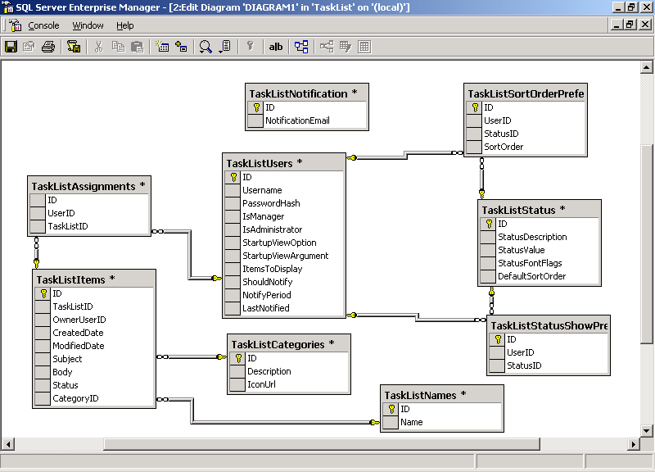

DATA FLOW DIAGRAM:

A data flow diagram is graphical tool used to describe and analyze movement of data through a system. These are the central tool and the basis from which the other components are developed. The transformation of data from input to output, through processed, may be described logically and independently of physical components associated with the system. These are known as the logical data flow diagrams. The physical data flow diagrams show the actual implements and movement of data between people, departments and workstations. A full description of a system actually consists of a set of data flow diagrams. Using two familiar notations Yourdon, Gane and Sarson notation develops the data flow diagrams. Each component in a DFD is labeled with a descriptive name. Process is further identified with a number that will be used for identification purpose. The development of DFD’s is done in several levels. Each process in lower level diagrams can be broken down into a more detailed DFD in the next level. The lop-level diagram is often called context diagram. It consists a single process bit, which plays vital role in studying the current system. The process in the context level diagram is exploded into other process at the first level DFD.

The idea behind the explosion of a process into more process is that understanding at one level of detail is exploded into greater detail at the next level. This is done until further explosion is necessary and an adequate amount of detail is described for analyst to understand the process.

Larry Constantine first developed the DFD as a way of expressing system requirements in a graphical from, this lead to the modular design.

A DFD is also known as a “bubble Chart” has the purpose of clarifying system requirements and identifying major transformations that will become programs in system design. So it is the starting point of the design to the lowest level of detail. A DFD consists of a series of bubbles joined by data flows in the system.

DFD SYMBOLS:

In the DFD, there are four symbols

- A square defines a source(originator) or destination of system data
- An arrow identifies data flow. It is the pipeline through which the information flows
- A circle or a bubble represents a process that transforms incoming data flow into outgoing data flows.
- An open rectangle is a data store, data at rest or a temporary repository of data

Process that transforms data flow.

Source or Destination of data

Data flow

Data Store

CONSTRUCTING A DFD:

Several rules of thumb are used in drawing DFD’s:

- Process should be named and numbered for an easy reference. Each name should be representative of the process.

- The direction of flow is from top to bottom and from left to right. Data Traditionally flow from source to the destination although they may flow back to the source. One way to indicate this is to draw long flow line back to a source. An alternative way is to repeat the source symbol as a destination. Since it is used more than once in the DFD it is marked with a short diagonal.
- When a process is exploded into lower level details, they are numbered.
- The names of data stores and destinations are written in capital letters. Process and dataflow names have the first letter of each work capitalized

A DFD typically shows the minimum contents of data store. Each data store should contain all the data elements that flow in and out.

Questionnaires should contain all the data elements that flow in and out. Missing interfaces redundancies and like is then accounted for often through interviews.

SAILENT FEATURES OF DFD’s

- The DFD shows flow of data, not of control loops and decision are controlled considerations do not appear on a DFD.

- The DFD does not indicate the time factor involved in any process whether the dataflows take place daily, weekly, monthly or yearly.
- The sequence of events is not brought out on the DFD.

TYPES OF DATA FLOW DIAGRAMS
- Current Physical
- Current Logical
- New Logical
- New Physical

CURRENT PHYSICAL:

In Current Physical DFD proecess label include the name of people or their positions or the names of computer systems that might provide some of the overall system-processing label includes an identification of the technology used to process the data. Similarly data flows and data stores are often labels with the names of the actual physical media on which data are stored such as file folders, computer files, business forms or computer tapes.

CURRENT LOGICAL:

The physical aspects at the system are removed as mush as possible so that the current system is reduced to its essence to the data and the processors that transform them regardless of actual physical form.

NEW LOGICAL:

This is exactly like a current logical model if the user were completely happy with he user were completely happy with the functionality of the current system but had problems with how it was implemented typically through the new logical model will differ from current logical model while having additional functions, absolute function removal and inefficient flows recognized.

NEW PHYSICAL:

The new physical represents only the physical implementation of the new system.

RULES GOVERNING THE DFD’S

PROCESS
- No process can have only outputs.
- No process can have only inputs. If an object has only inputs than it must be a sink.
- A process has a verb phrase label.

DATA STORE
- Data cannot move directly from one data store to another data store, a process must move data.
- Data cannot move directly from an outside source to a data store, a process, which receives, must move data from the source and place the data into data store
- A data store has a noun phrase label.

SOURCE OR SINK
The origin and /or destination of data.

- Data cannot move direly from a source to sink it must be moved by a process
- A source and /or sink has a noun phrase land

DATA FLOW
- A Data Flow has only one direction of flow between symbol. It may flow in both directions between a process and a data store to show a read before an update. The later is usually indicated however by two separate arrows since these happen at different type.
- A join in DFD means that exactly the same data comes from any of two or more different processes data store or sink to a common location.
- A data flow cannot go directly back to the same process it leads. There must be atleast one other process that handles the data flow produce some other data flow returns the original data into the beginning process.
- A Data flow to a data store means update ( delete or change).
- A data Flow from a data store means retrieve or use.
A data flow has a noun phrase label more than one data flow noun phrase can appear on a single arrow as long as all of the flows on the same arrow move together as one package.

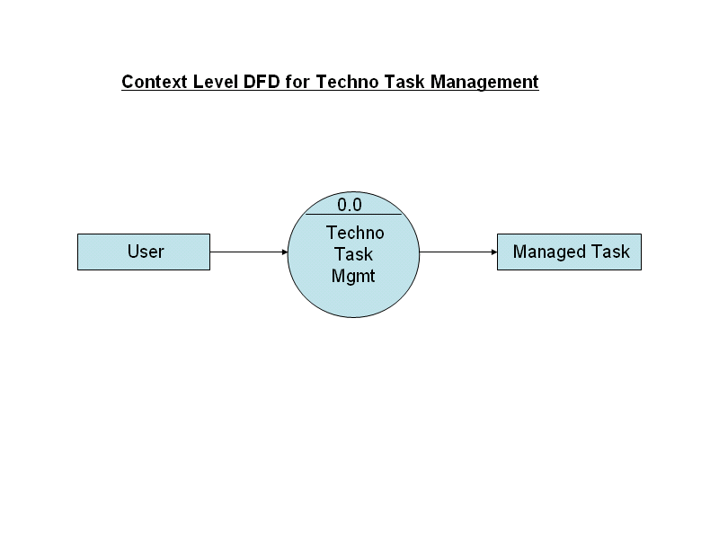

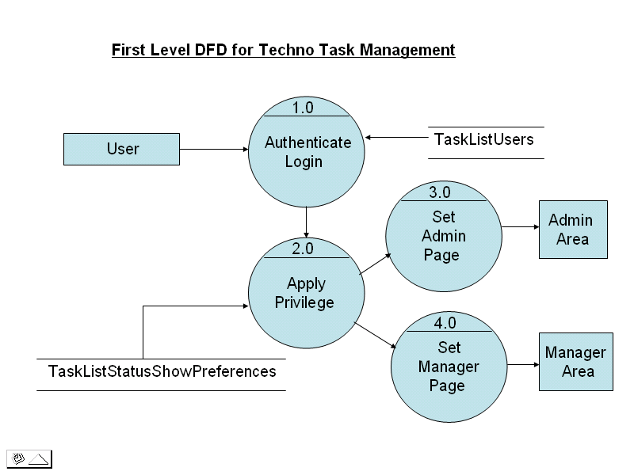

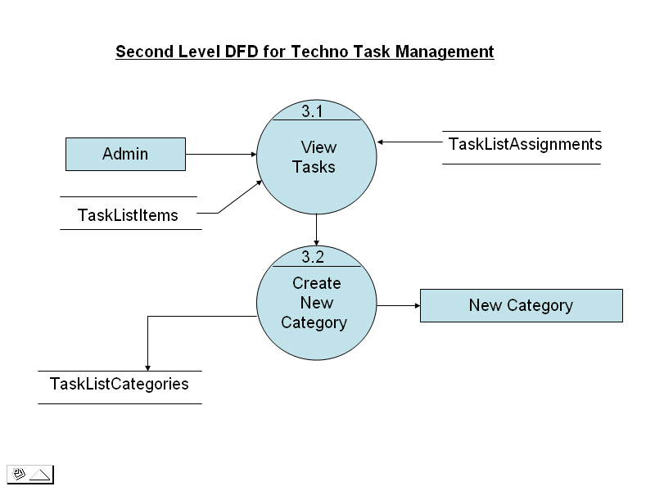

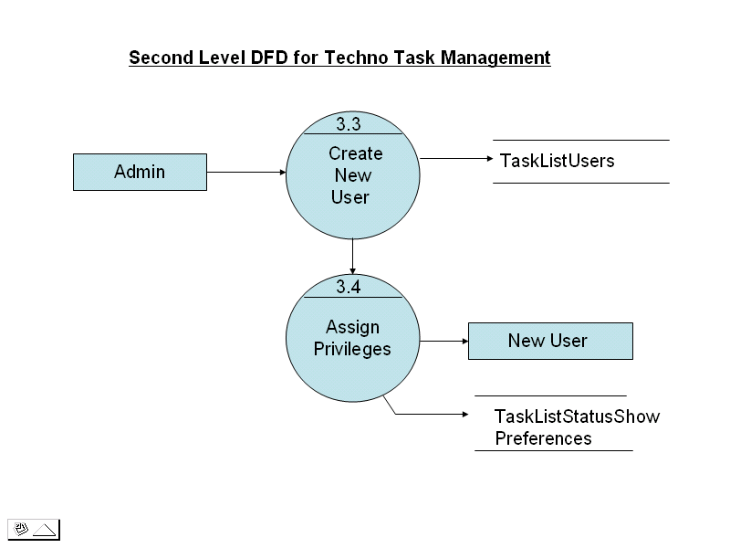

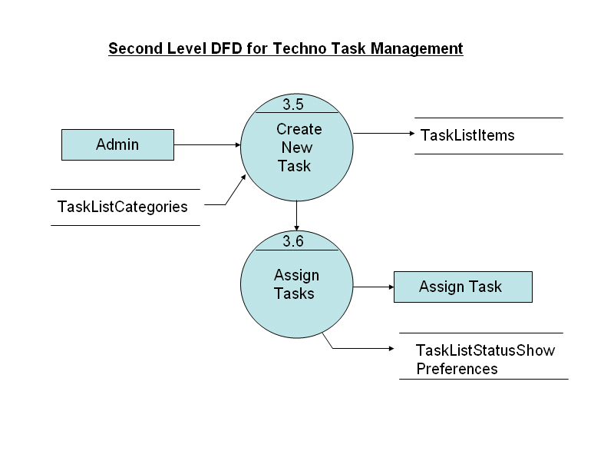

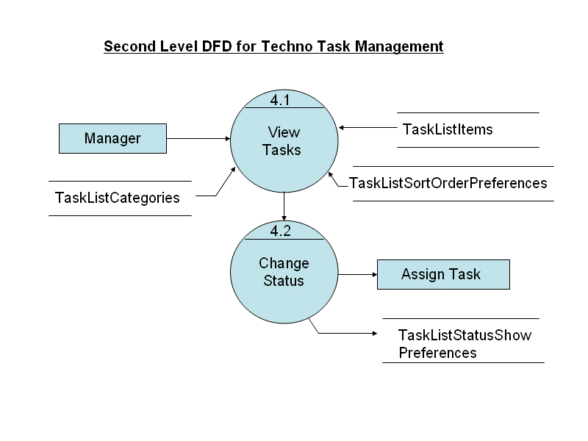

SCREENS

Administrator Login:

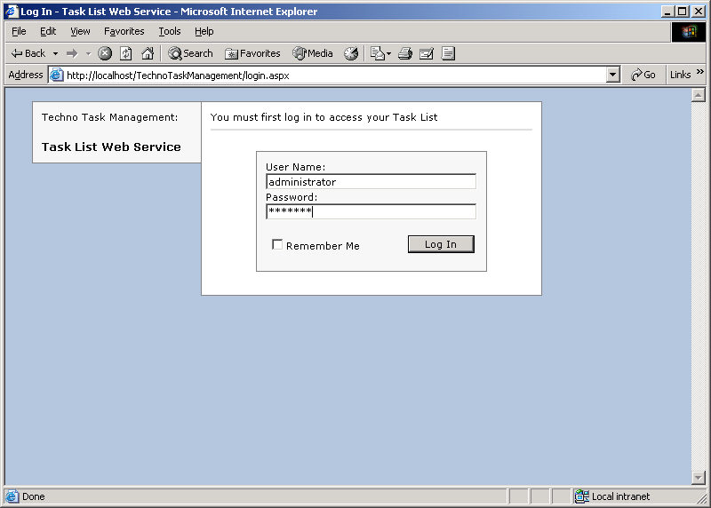

Task List Display:

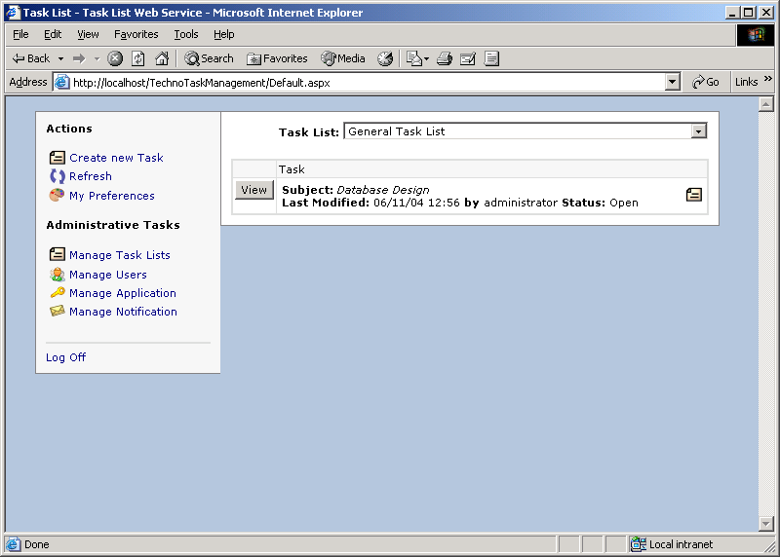

Creating New task:

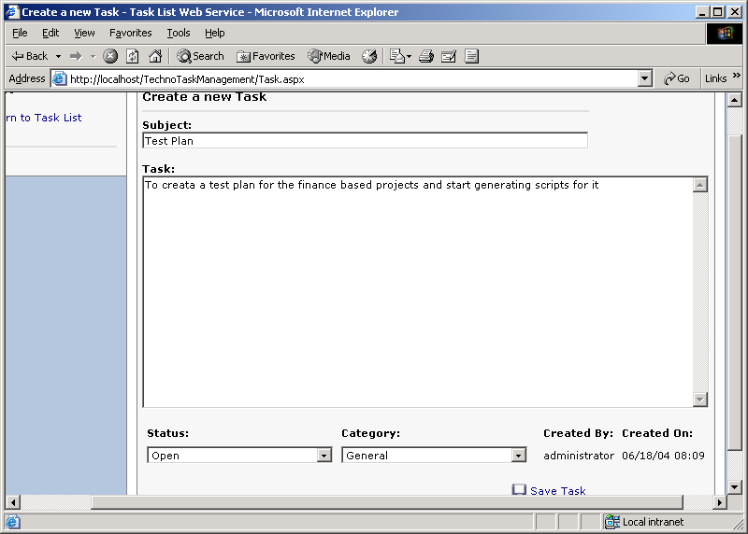

Newly Created Task:

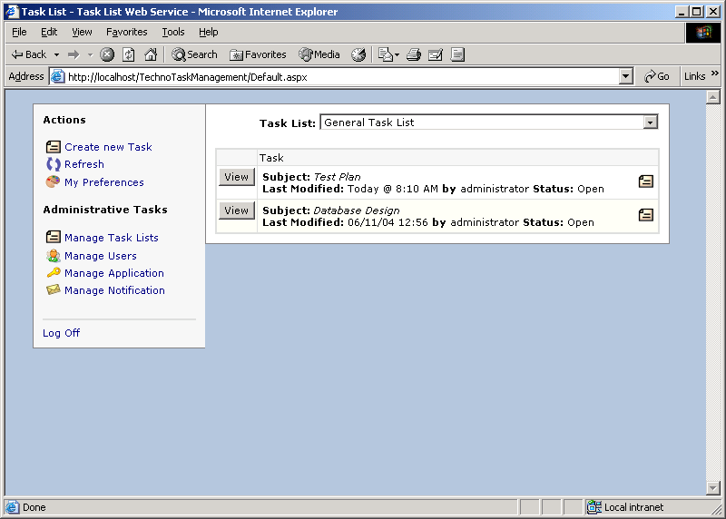

Preferences Settings:

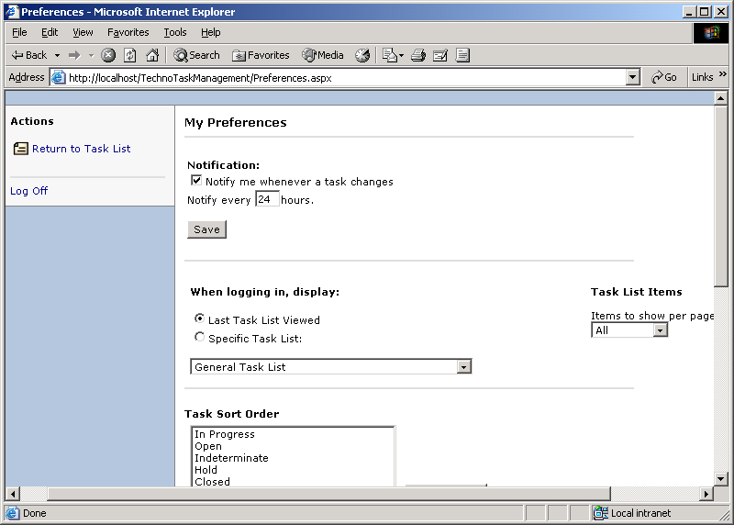

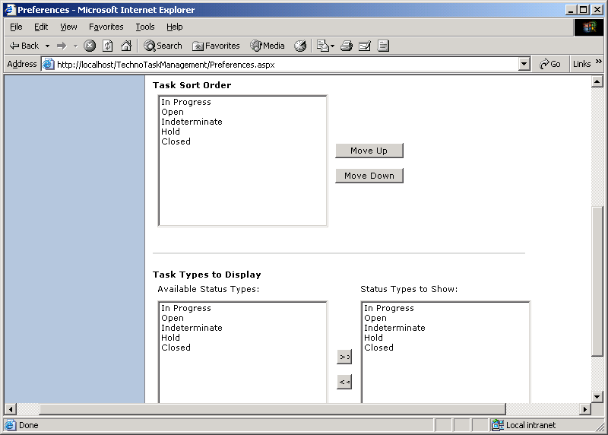

Task List Properties:

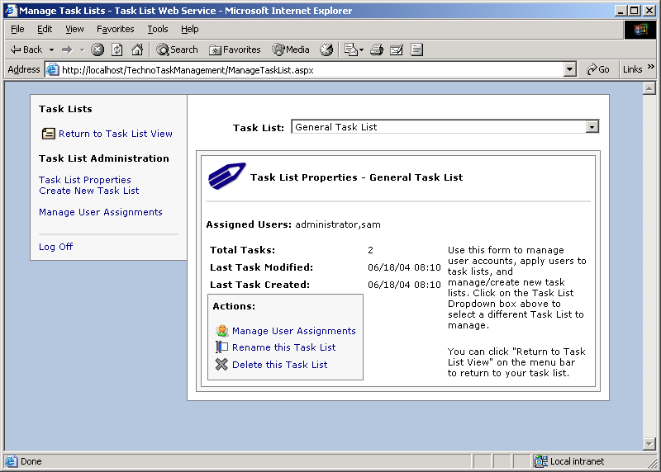

User Assignments:

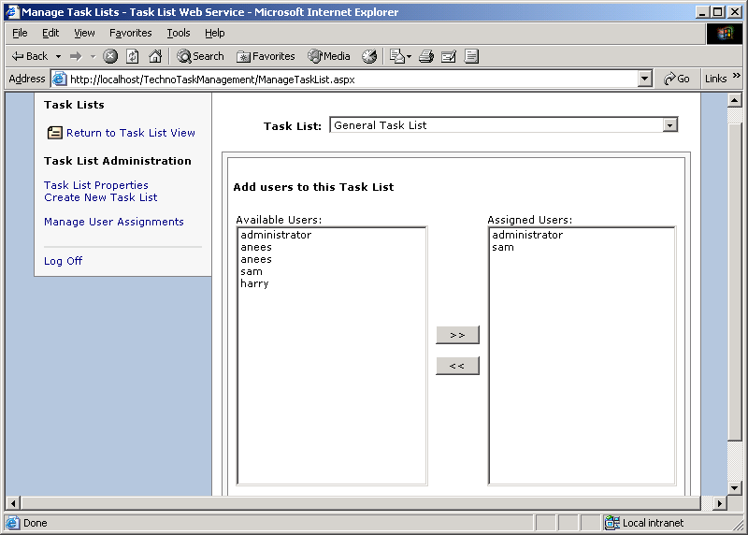

Creating New Task List:

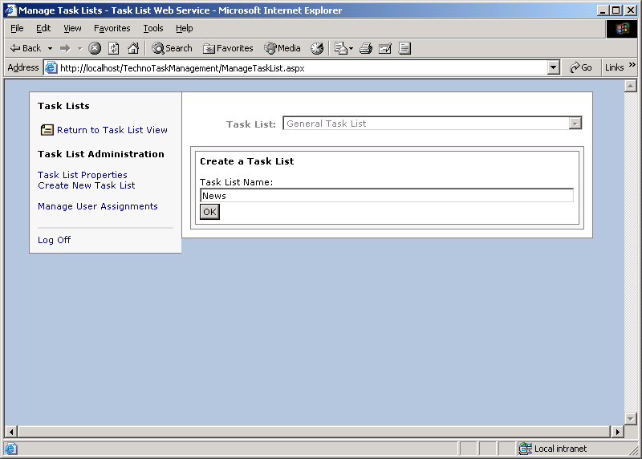

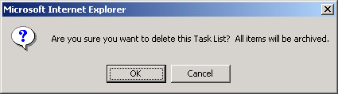

Renaming the Existing Tasklist:

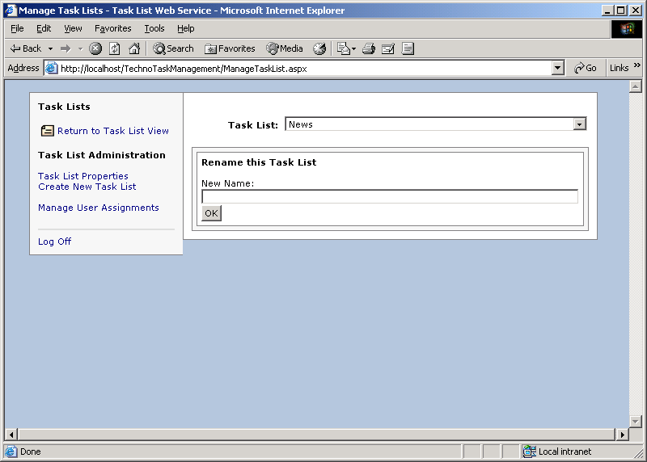

User Configuration:

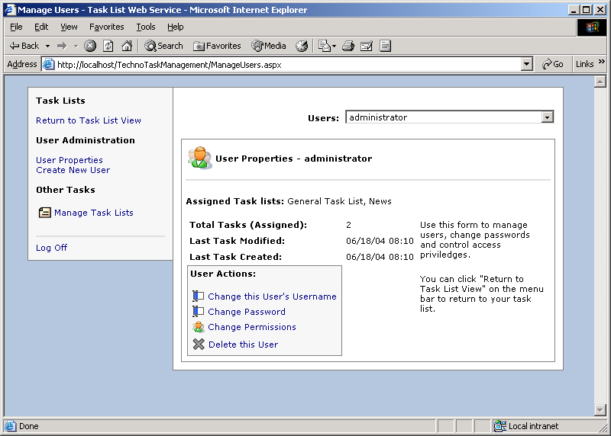

Changing UserName:

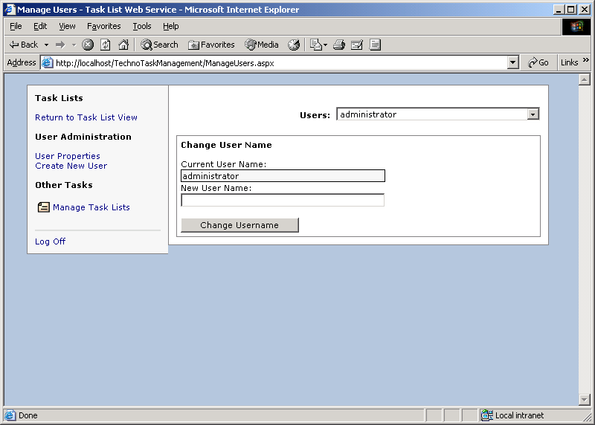

Changing Password:

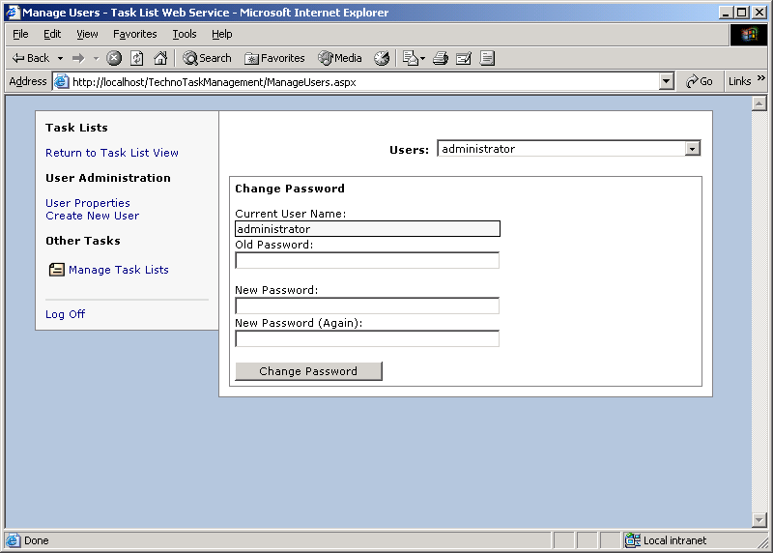

Changing Permissions:

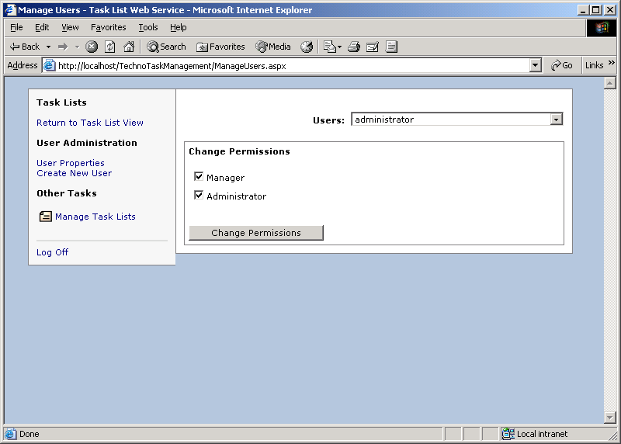

Delete Confirmation:

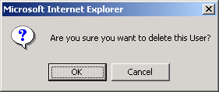

Creating New User:

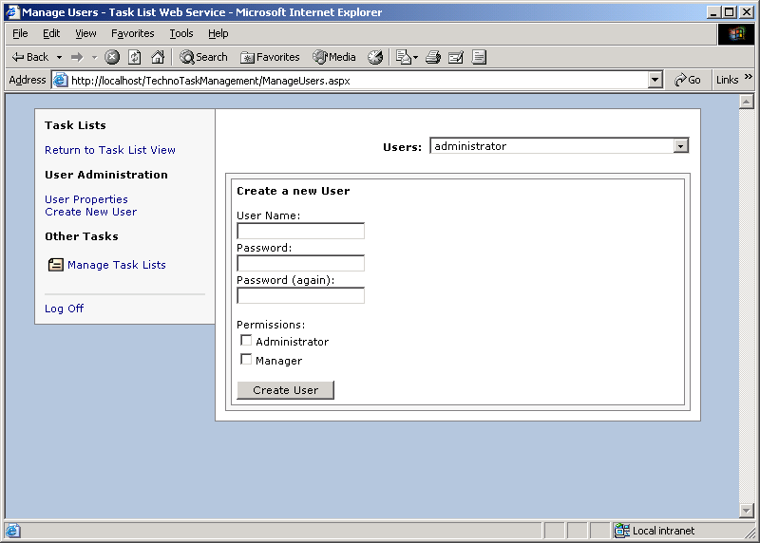

Configuring Application States:

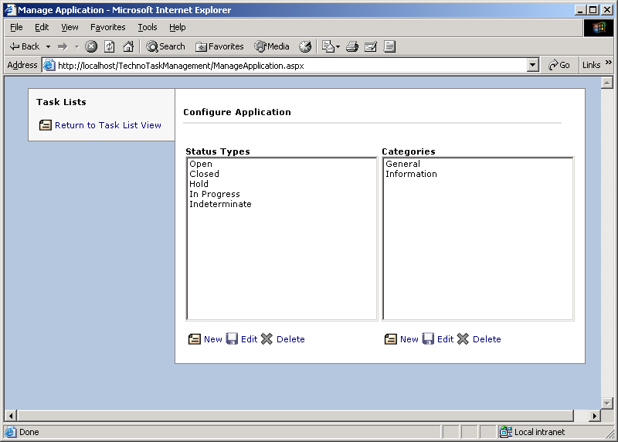

Notification Area:

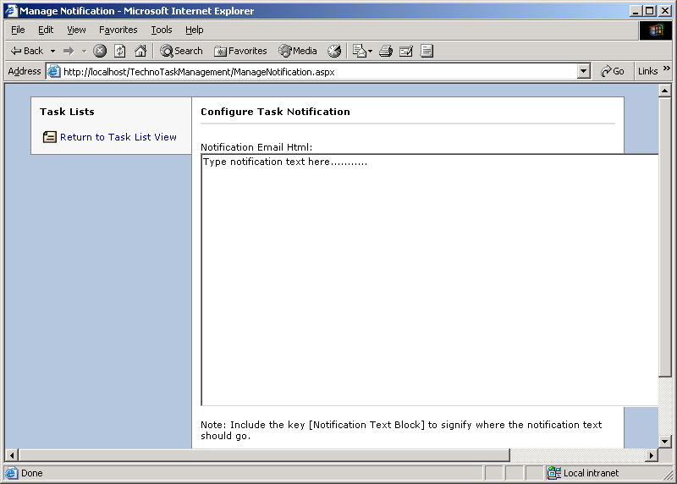

Viewing the Tasks:

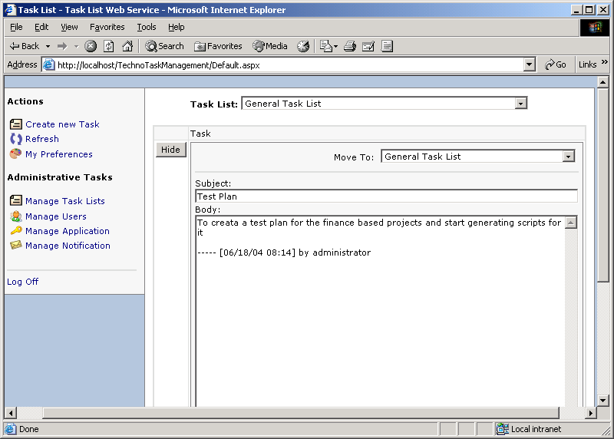

Moving Task from one category to other:

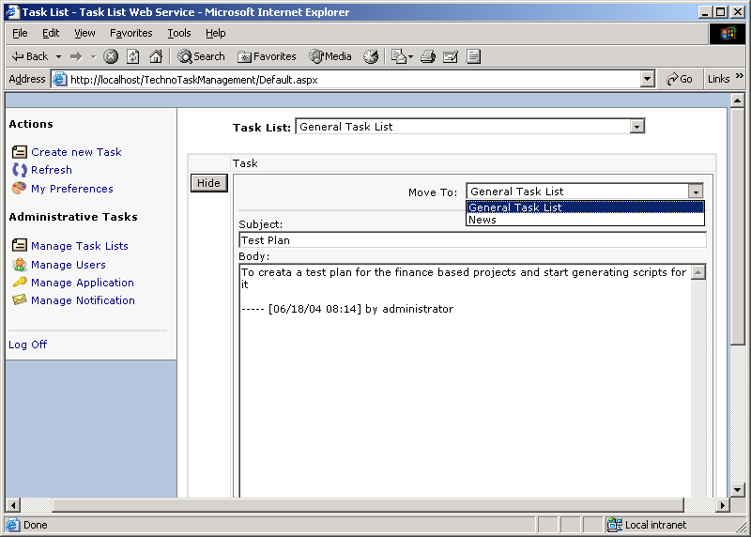

Changing the state of Task:

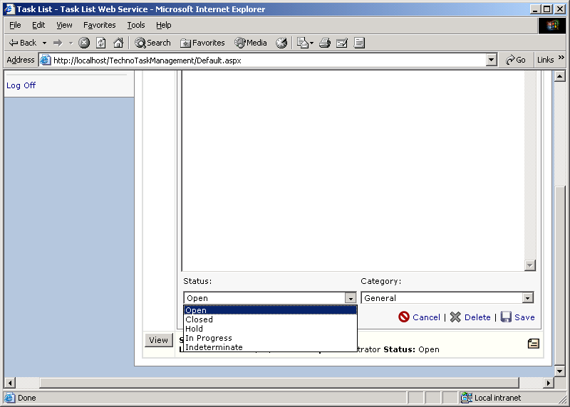

Task list with Changed State:

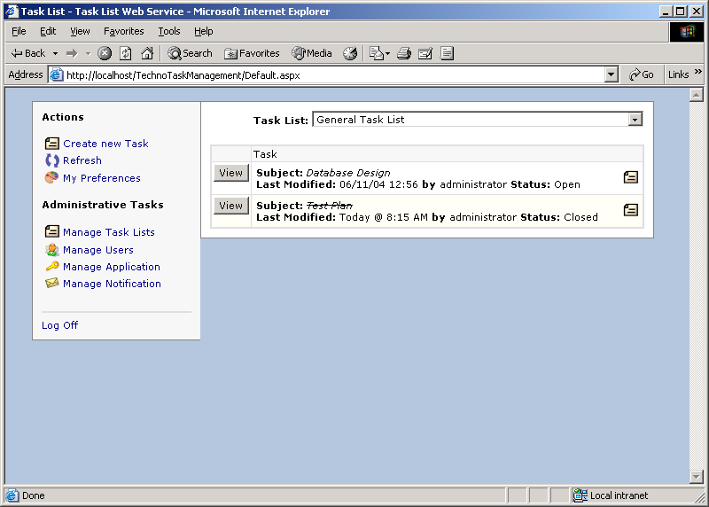

User with unassigned Task list:

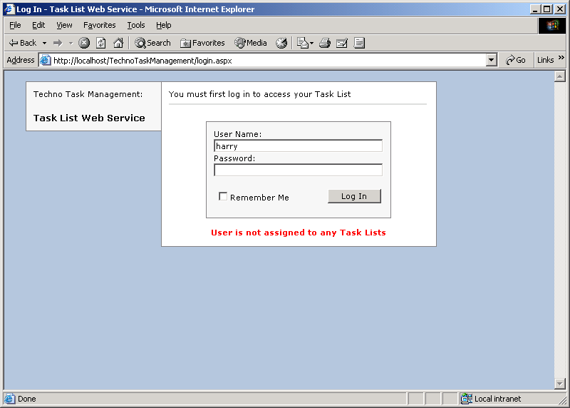

PROJECT TESTING

- COMPILATION TEST:
- It was a good idea to do our stress testing early on, because it gave us time to fix some of the unexpected deadlocks and stability problems that only occurred when components were exposed to very high transaction volumes.

- EXECUTION TEST:

- This program was successfully loaded and executed. Because of good programming there were no execution error.

- OUTPUT TEST:

- The successful output screens are placed in the output screens section.

FUTURE SCOPE OF PROJECT

The application is capable of managing only tasks and their respective allotments where as there is not scope of communication between two groups or between the employees other than mail notification. The information between them is still in terms of documents. The application can improve in these areas of communication and document preservation as well as client maintenance.

The application can be converted into a Mobile based using ASP.net with which the deployment of application will be done only on enterprises server and is accessible to all other departments of the organization. The current application is confined to only one enterprise.

CONCLUSION

- The project has been appreciated by all the users in the organization.
- It is easy to use, since it uses the GUI provided in the user dialog.
- User friendly screens are provided.
- The usage of software increases the efficiency, decreases the effort.
- It has been efficiently employed as a Task management mechanism.
- It has been thoroughly tested and implemented.

BIBLIOGRAPHY

SOFTWARE ENGINEERING
By Roger.S. Pressman

SQL FOR PROFESSIONALS
By Jain

VISUAL BASIC.NET Black Book
By Evangeleous Petereous

ASP.Net Professional
By Wrox Publications

MSDN 2002
By Microsoft

